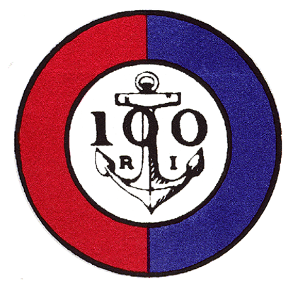

The 100 Club of Rhode Island, Inc.
Recipients of the 100 Club Academic Scholarship
2022

Adam J. Aguiar
Zachary S. Baughan
Mia R. Clarke
Alexander T. Crowley
Nathan H. Fernandes
Alice C. Grantham
Samuel M. Leclaire
Isabella T. Livoli
Sean V. O’Briien
Sofia L. Quattrini

